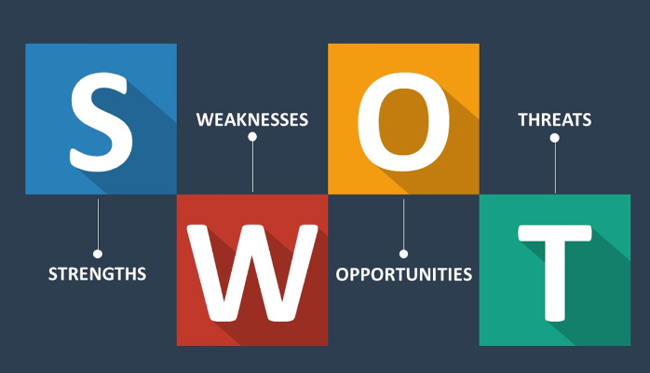

Use the following questions to support you in conducting a self SWOT analysis:

**Strengths (don’t be modest):**

* How do your education, skills, talents, certifications, and connections / networks set you apart from your peers?
* What would your boss or coworkers say are your strengths?
* What resources do you have at your disposal?
* What contributed the most to your past victories?
* What values or ethics do you have that your peers often lack?
* What achievements are you most proud of?

**Weaknesses (be honest):**

* Where are your education, training, or skills lacking? What’s missing and needs improvement?
* What would your boss or coworkers say are your weaknesses or areas of improvement?
* What are your negative work habits and personality traits?  
   What do you avoid because you lack confidence?

**Opportunities:**

* Which opportunities are you not exploiting at the moment?
* What trends are affecting your industry – the industry you belong to or wish to be in?
* In what areas is your industry growing?
* How could new technology help you advance?
* How could your connections and networks help you?

**Threats:**

* What obstacles do you currently face in your career and life?
* Who is your competition?
* Will new technology or certifications demands slow your progress in achieving your goals?
* How is your job or industry changing in ways that could affect your advancement?

S.W.O.T

|  |  |
| --- | --- |
| **Strengths**   * I am brave and stand for what I want. * I do complete tasks on time, cheerleader, Good customer care, dedication and commitment. * Hunger to learn and to be a better person, burden to change the society. * Hard work, determination and positive attitude. * Making clients happy, ability to learn new things and also getting a grasp of the market. * I know how to fit in anywhere. I am a natural. * I have acquired 2 discipline certificates and a guiding and counseling certificate. | **Weaknesses**   * There is no enough practice to perfect my skills. * At times communication becomes a problem to me. * I love things done my way. * Spending more time on unnecessary things and also missing out in trying something new due to the fear of failure. |
| **Opportunities**   * The fact that i get to visit new places and also interact with many people and be here in Akirachix to expand my knowledge in technology industry. * There is more tutorials in the internet that helps me learn more. * I have more time to grow myself in many dimensions. * Time to work on my confidence. | **Threats**   * Since there are other tech gurus out there, it contributes to high competition and hence leaves me no other option than to perfect my skills so as to compete with them and secure a good place. * I really want to come up with my own ideas and be an entrepreneur and somehow I feel like I have not acquired all I need to set up my own business. i.e. my source of capital. |